|  |  |
| --- | --- |
|  |  |
|  | **X Sushi Bar**  **Location plan** |
|  |  |
|  |  |

Summary

X Sushi Restaurant, LLC is a standard sushi bar business that will be located in Toronto Ontario Canada. The restaurant will be involved in full-service dining sushi sales, beverage sales and take-out sushi sales et al. There are many large and small sushi restaurants all around Toronto, which is why we spent time and resources to conduct our ‘location searching plan’.

Here are some bullet points on the desired location:

* A neighborhood with college students
* Walking distance from major office buildings
* Limited number of competitors nearby

Choice of Neighborhood

Downtown, near University of Toronto

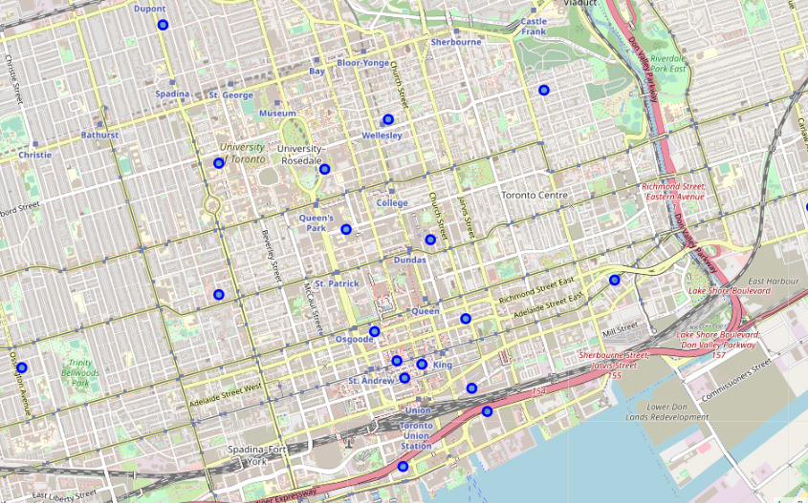

Narrow down the searching area

University of Toronto is the largest university in downtown. Bay street is where major banks and financial institutions located at. There are high demands for food delivery and business lunch.

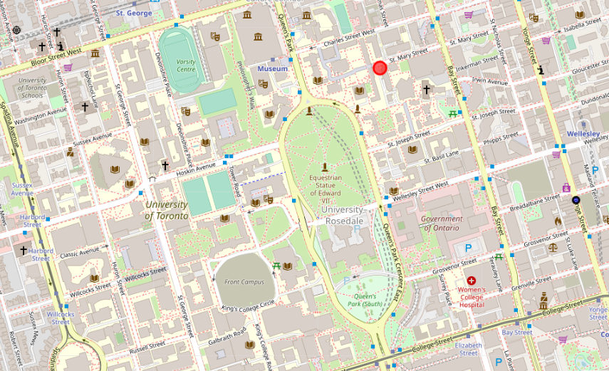

Ryerson University is another major university in down town.

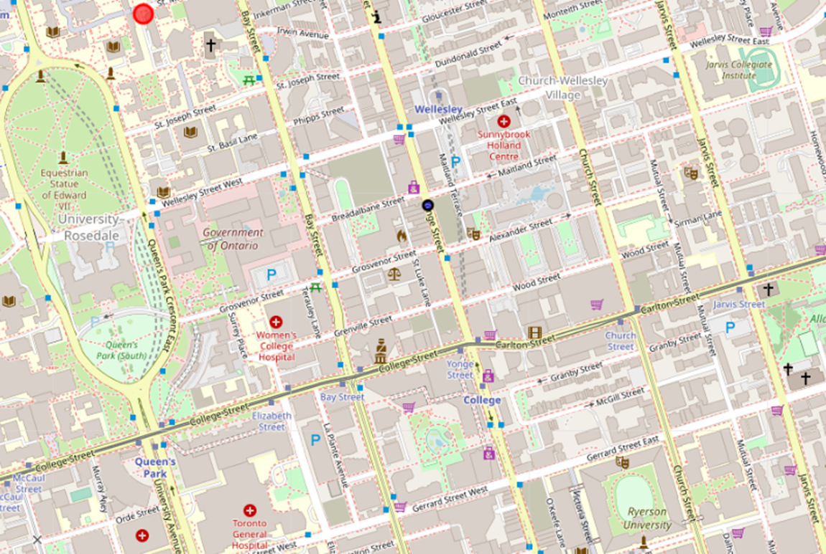

Competitors

5 Japanese restaurants but given the students and offices population, there should be enough demand.

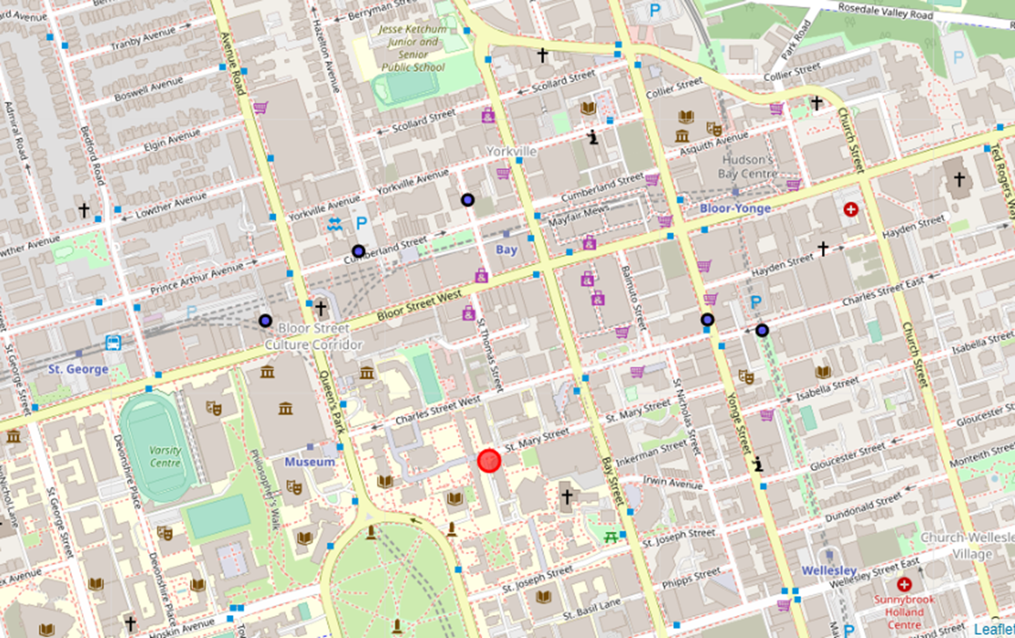

Final Decision

